OPERATOR OVERLOADING
1.Plus
#include <iostream>
using namespace std;
class Complex {
private:
float real;
float imag;
public:
Complex(float r = 0, float i = 0) {
real = r;
imag = i;
}
Complex operator + (const Complex &c) {
Complex temp;
temp.real = real + c.real;
temp.imag = imag + c.imag;
return temp;
}
void display() {
cout << real;
if (imag >= 0)
cout << " + " << imag << "i" << endl;
else
cout << " - " << -imag << "i" << endl;
}
};
int main() {
float r1, i1, r2, i2;
cout << "Enter real and imaginary part of first complex number: ";
cin >> r1 >> i1;
cout << "Enter real and imaginary part of second complex number: ";
cin >> r2 >> i2;
Complex c1(r1, i1);
Complex c2(r2, i2);
Complex sum = c1 + c2;
cout << "First complex number: ";
c1.display();
cout << "Second complex number: ";
c2.display();
cout << "Sum of complex numbers: ";
sum.display();
return 0;
}
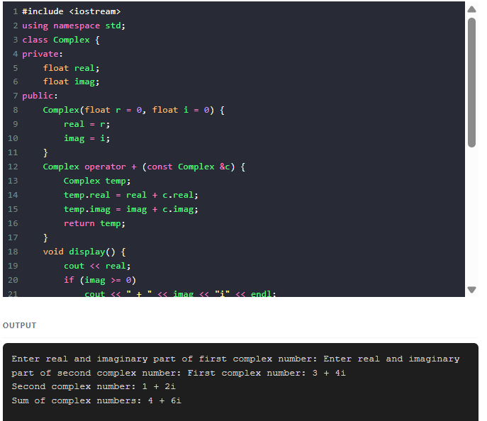
2.Increment
#include <iostream>
using namespace std;
class Counter {
int value;
public:
Counter(int v = 0) : value(v) {}
// Pre-increment (++c)
Counter& operator++() {
value++;
return *this;
}
// Post-increment (c++)
Counter operator++(int) {
Counter temp = *this;
value++;
return temp;
}
void display() const {
cout << "Value = " << value << endl;
}
};
int main() {
Counter c(10);
cout << "Initial: ";
c.display();
cout << "After pre-increment (++c): ";
++c;
c.display();
cout << "After post-increment (c++): ";
c++;
c.display();
return 0;
}

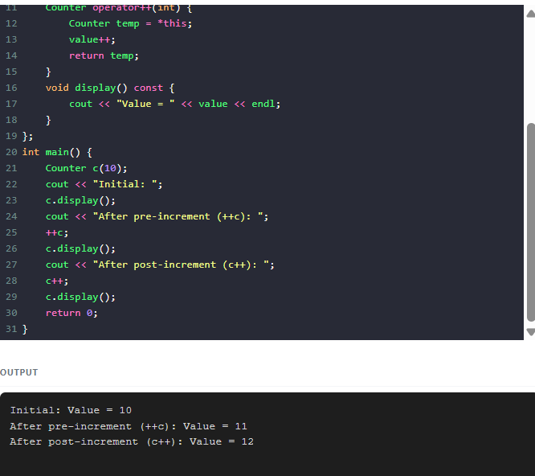
3.<<
#include <iostream>
using namespace std;
class Student {
private:
int roll;
string name;
float marks;
public:
Student(int r, string n, float m) : roll(r), name(n), marks(m) {}
// Overload << operator as a friend function
friend ostream& operator<<(ostream& out, const Student& s) {
out << "Roll No: " << s.roll
<< "\nName: " << s.name
<< "\nMarks: " << s.marks;
return out;
}
};
int main() {
Student s1(1924, "ramyya", 89.0f);
cout << s1;
return 0;
}
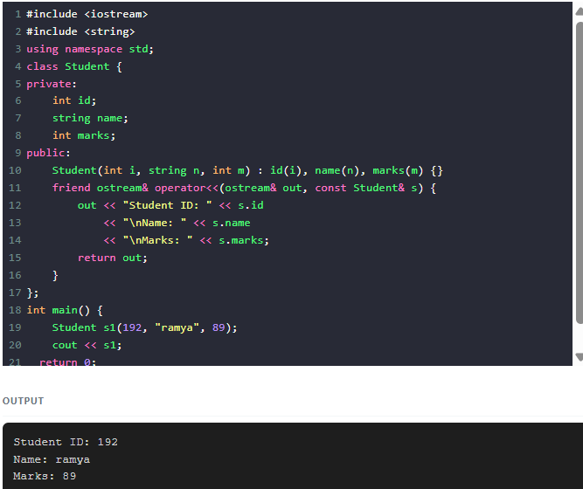

4. Equal
#include <iostream>
using namespace std;
class Student {
private:
int id;
string name;
public:
// Constructor
Student(int i, string n) {
id = i;
name = n;
}
// Overload == operator
bool operator==(const Student& other) const {
return (id == other.id && name == other.name);
}
};
int main() {
Student s1(101, "Alice");
Student s2(101, "Alice");
Student s3(102, "Bob");
cout << boolalpha; // print true/false
cout << "s1 == s2 : " << (s1 == s2) << endl; // true
cout << "s1 == s3 : " << (s1 == s3) << endl; // false
return 0;
}

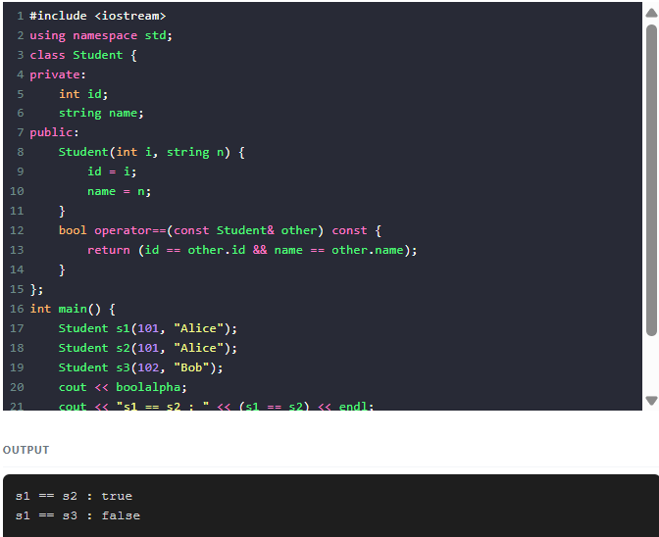
5.[]
#include <iostream>
using namespace std;
class Array {
private:
int arr[5];
public:
Array() {
for (int i = 0; i < 5; i++) {
arr[i] = (i + 1) * 10; // Example values: 10, 20, 30, 40, 50
}
}
// Overload [] operator
int& operator[](int index) {
// (Optional) index checking
if (index < 0 || index >= 5) {
cout << "Index out of bounds!\n";
// Return first element by reference to avoid undefined behavior
return arr[0];
}
return arr[index];
}
};
int main() {
Array a;
cout << "Element at index 2: " << a[2] << endl;
// Demonstrate modification using overloaded []
a[2] = 999;
cout << "After updating, element at index 2: " << a[2] << endl;
return 0;
}
